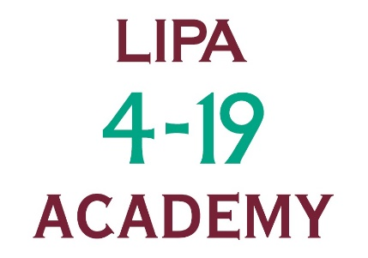
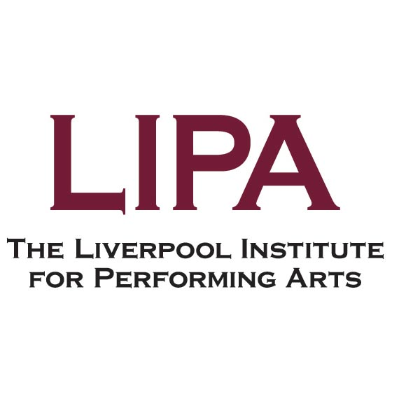

Job Description

Job Title | Singing Teacher
Salary Scale | LIPA 4-19 Scale - £34.23 per hour inclusive of holiday pay
Department | LIPA 4-19 Academy
Responsible To | LIPA 4-19 Programme Leader
Responsible For | No subordinate staff
Number in Post | Varies
Date Drafted | July 2026

Job Purpose
To provide the LIPA 4-19 with leading edge expertise in the area of singing and training children and young people to required standards, preparing them for productions and performances.

Major Tasks
- Deliver teaching sessions to students of different ages (16+ years).
- Where necessary, to offer individual coaching and advice to students in the area of singing.
- To prepare songs and musical theatre pieces for end of year productions.
- Duties common to all LIPA staff.

Job Activities
Major Task 1: Deliver Teaching Sessions
- Prepare sessions to ensure a wide, exciting variety of singing teaching for students at LIPA 4-19.
- Follow the LIPA 4-19 curriculum.
- Arrange song and musical theatre pieces, directing students as appropriate.
- Correct singing technique, including breath control.
- Provide song interpretation and presentation skills.
Major Task 2: Individual Coaching and Advice
- Provide advice on vocal technique, anatomy, diction and placement.
- Coach on pitch and harmony.
Major Task 3: Preparation of Song and Musical theatre pieces for end of year productions
- Select appropriate music according to student capability.
- Arrange pieces for professional productions.
- Support acting and dance tutors in terms of bringing musical and vocal awareness to the other disciplines.
- Work with other staff to co-ordinate the term productions in terms of presentation, administrative/operational requirements.
- Co-ordinate the singing students during productions.
Major Task 4: Common Duties
- Works flexibly, including contributing to LIPA 4-19 work projects of a general nature and providing cover for other staff.
- Participates in staff appraisals and training programmes as required.
- Carries out duties at all times with due regard to Equality and Diversity, Health and Safety and other LIPA 4-19 policies as agreed and revised from time to time.

Notes:
This job description will be reviewed annually as part of the appraisal process and may be varied in the light of LIPA 4-19’s changing business needs. The job description sets out the main duties of the post at the date it was drafted. Such duties may vary from time to time without changing the general character of the post or the level of responsibility entailed.
Location:
Hours are available at our main site on Mount Street. It may be that from time to time the postholder will be required to work on different duties, or in any other jobs, within his / her competence, such jobs being in his / her present or any other location as may be deemed appropriate. In all cases regard will be paid to the qualifications, experience, current duties and responsibilities and personal circumstances of the post holder.
Hours:
The actual teaching sessions will be 10am – 1pm and 2:30pm – 5:30pm on Saturdays (although you will be expected to arrive in good time to collect or register your classes).
Periodically meetings may need to be held in order to plan and inform staff working on the Programme. In these instances, we will ensure you receive payment for your attendance at an appropriate rate.

Person Specification - Singing Teacher (LIPA 4-19)
 |  | To be identified by:
Education and Qualifications:
Formal singing qualification from a recognised institution. | Desirable | Application Form /Certificates
Experience / Knowledge:
Professional singing experience. | Essential | Application Form/ Interview
Experience and understanding of a large variety of musical genres, including musical theatre, pop, jazz, rock and classical. | Essential | Interview
Experience of creating vocal arrangements including harmony. | Desirable | Application Form/ Interview
Musical Theatre experience. | Desirable | Application Form/ Interview
Experience of working with young people in a teaching environment. | Essential | Application Form / Interview
Skills and Ability:
Innovative, creative and adaptable. | Essential | Interview
Ability to work well in a team. | Essential | Interview
Enjoy working with young people. | Essential | Interview
Able to play the piano. | Desirable | Application Form
Commitment:
To Equality and Diversity Policies and Practice. | Essential | Interview
To the provision of a high level of service to the customers of the Academy. | Essential | Interview
Enthusiasm and flexibility. | Essential | Interview

